**Planning and Recall Conversations**

**Make All the Difference**

Shannon D. Lockhart

[slockhart@highscope.org](mailto:slockhart@highscope.org)

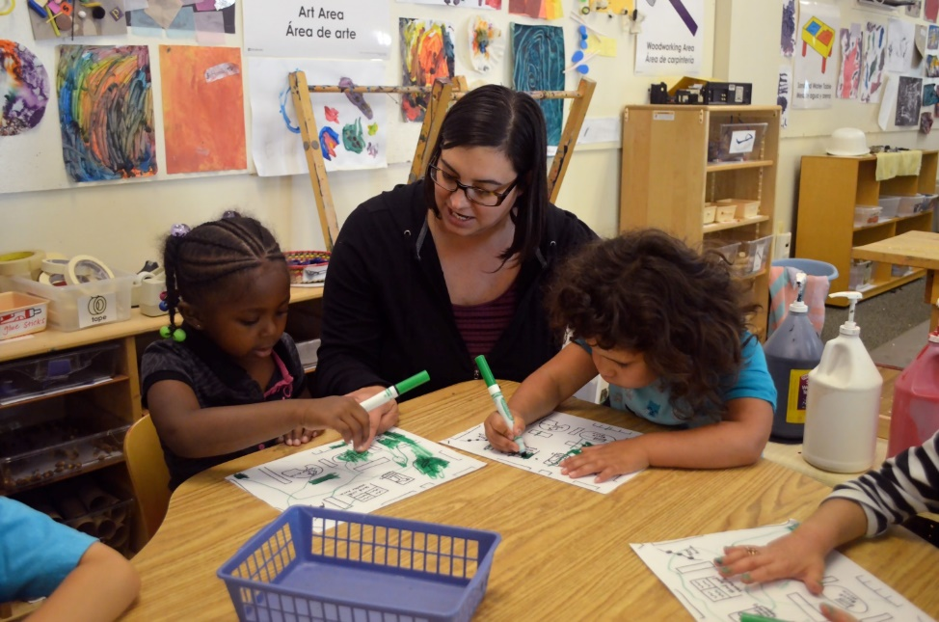

**Components of Executive Function**

1. Working Memory—ability to hold and manipulate information over short periods of time. Essential feature is holding information in mind and actively using it to guide thinking and behavior. Draws on past learning or experiences to apply to the situation at hand or to project into the future.
2. Inhibition—skill we use to master and filter our thoughts and impulses so we can resist temptation, distractions, and habits and to pause and think before we act. Being intentional in how we regulate our behaviors.
3. Cognitive Flexibility—capacity to nimbly switch gears and adjust to changed demands, priorities, or perspectives. “Thinking outside the box.”

(Center on the Developing Child Harvard University – [www.developingchild.harvard.edu](http://www.developingchild.harvard.edu))

**Planning Time Checklist: How Adults Support Children at Planning Time**

**Establish a consistent planning time within the daily routine.**

* 10–15-minute block of time
* Plan in a consistent place where people, interest areas, and materials are visible
* Plan with a consistent adult and small group of children
* Use planning activities to help children think about materials, space, and people
* Modify the planning activity to support individual children at their own developmental level
* Allow children to get started right away after they plan (do not wait for the whole group to finish)

**Converse with children and scaffold their plans**

* Encourage children to plan at their own developmental levels (e.g., looking, pointing, speaking, drawing, writing).
* Listen attentively and acknowledge the choices and decisions all children make so children begin to see themselves as decision makers.
  + Interpret children’s gestures and actions such as pointing to materials or classroom areas
  + Repeat or restate children’s words
  + Offer suggestions when children do not respond
* Ask open-ended questions to help children think about
  + Materials
  + Space and classroom areas
  + People
* Help children sequence the steps in their plans
* Help children anticipate and think through solutions to potential barriers/problems
* Talk with children about previous play, prior work, or related materials or interests.
* Encourage playmates to plan together
* Re-plan with children during work time if it appears that they are wandering or unfocused

**Recall Time Checklist: How Adults Support Children at Recall Time**

**Establish a consistent recall time within the daily routine.**

* Recall in a consistent place where people, interest areas, and materials are visible.
* Recall with a consistent small group of children.
* Physically separate recall groups as much as possible to reduce distractions
* Use recall activities to gain children’s attention and to help children think about materials, space, and people
* Take an unhurried approach and give children time to remember their worktime actions and accomplishments

**Converse with children**

* Take an unhurried approach.
* Encourage children to recall at their own developmental levels (e.g., looking, pointing, speaking, drawing, writing).
* Encourage a group conversation and support children’s co-narratives and different viewpoints
* Listen attentively and allow children to decide what aspects of work time they recall
  + Interpret children’s gestures such as pointing to materials or classroom areas
  + Repeat or restate children’s words
  + Contribute your own observations about what the child did at worktime
  + Encourage other children to add observations
* Ask open-ended questions to help children think about
  + Materials
  + Space and classroom areas
  + People
  + Original plans
* Help children remember the sequence of steps in their play
* Encourage children to describe accomplishments or solutions to problems encountered at work time.
* Connect children’s work time actions and accomplishments to their plans (e.g., Remark when children follow through on their intentions).

**Planning and Recall Conversation Starters and Extenders**

**Planning Time**

* + You are pointing to the art area. Touch something you want to use.
  + How you will use…?
  + What will you use to help you…?
  + How will you…?
  + What will happen if...?
  + What will you need?
  + Tell me more about how that will look?
  + Tell me more about how that will work?
  + Will you work with anyone else?
  + Will you need someone else to help you?
  + Who will work/play with you?
  + Will you need anything from another area?
  + Will you stay there all of work time or do you have another plan?
  + Have you thought about…?
  + What are some things you know about…?
  + What will you do today that is different from yesterday?
  + Where did you get that idea?
  + What made you think of that?
  + What will you use to help you…?
  + You’re really interested in… What other things have you found out/do you want to learn out…?

**Recall Time**

* + I saw you in the house area. Tell me about that.
  + Show me something you used.
  + Tell me about what you were doing?
  + What did you do in that area?
  + What was your plan for today? Did you do that?
  + So your plan changed… What happened?
  + How did you figure that out?
  + How did you solve that problem?
  + How did that work?
  + Where did you get that idea?
  + What else did you do?
  + How did you use those materials?
  + Where else did you play?
  + Who did you play with?
  + What happen when…?
  + What else do you want to share?
  + How would you change…?
  + What else could you do?
  + What will you do next time?

**Implementation Plan**

1. What are your strengths of planning and recall time?
2. What aspects of planning and recall do you want to change or begin implementing?

C:\Users\ShannonL\AppData\Local\Microsoft\Windows\Temporary Internet Files\Content.IE5\M47WTWOR\MC900078748[1].wmf

1. How will you build in more conversation starters with your children according to their developmental levels and their growth in planning and recalling?
2. How will you build on children’s thoughts and ideas to extend their conversations during planning and recall times?

C:\Users\ShannonL\AppData\Local\Microsoft\Windows\Temporary Internet Files\Content.IE5\KLRBT61N\MC900078732[1].wmf